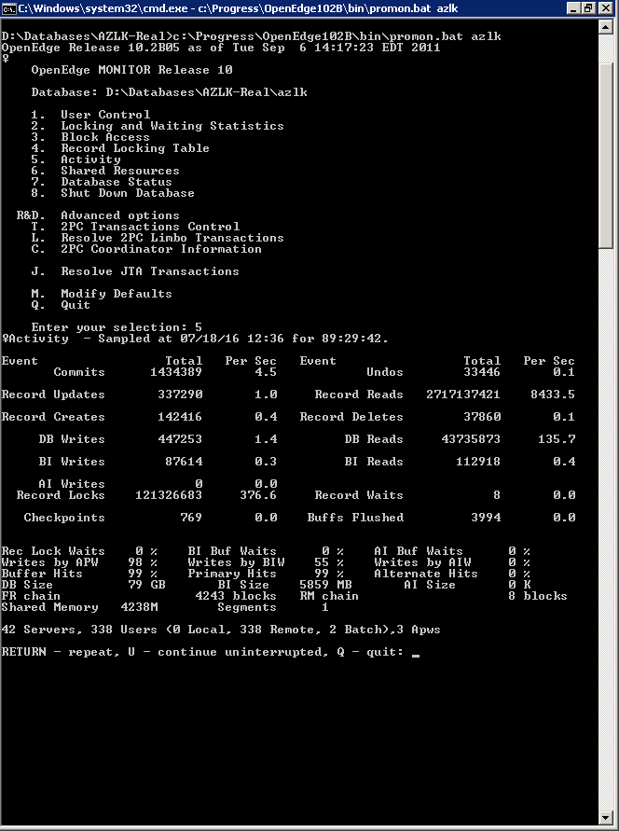

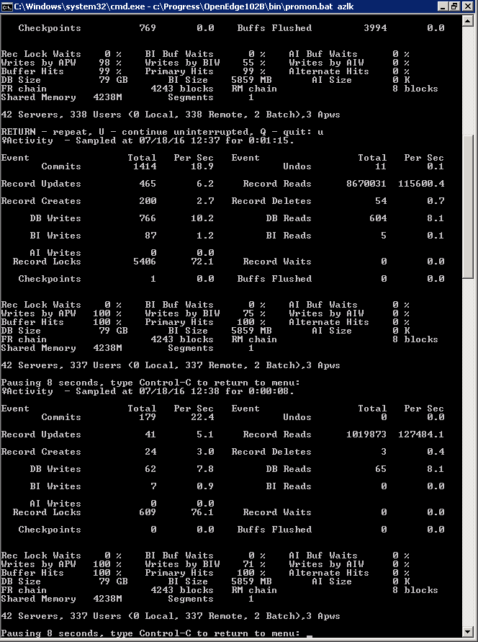

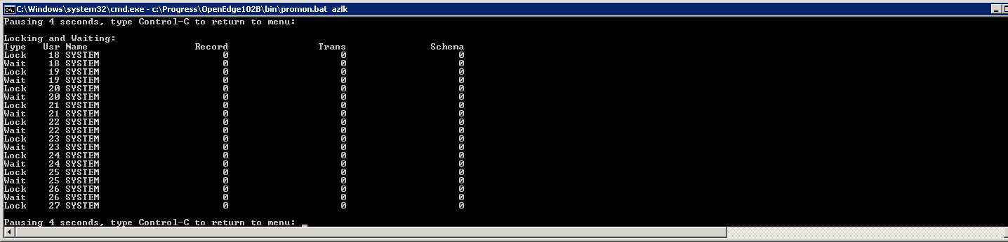

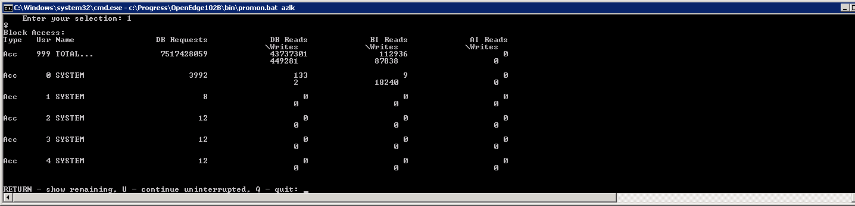

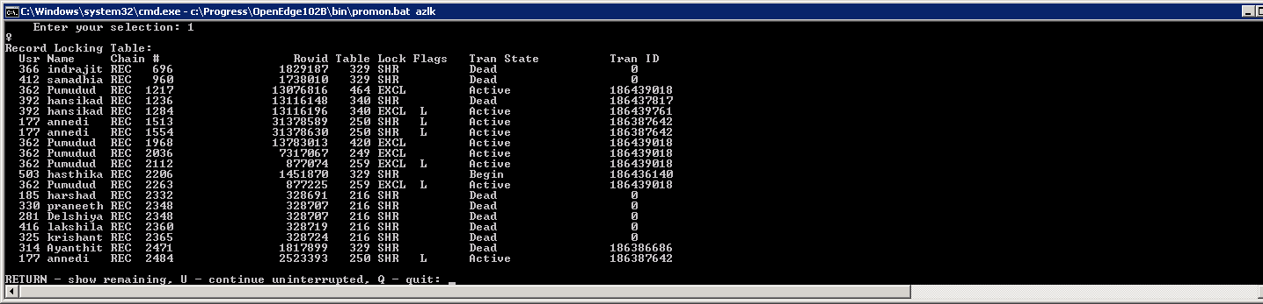

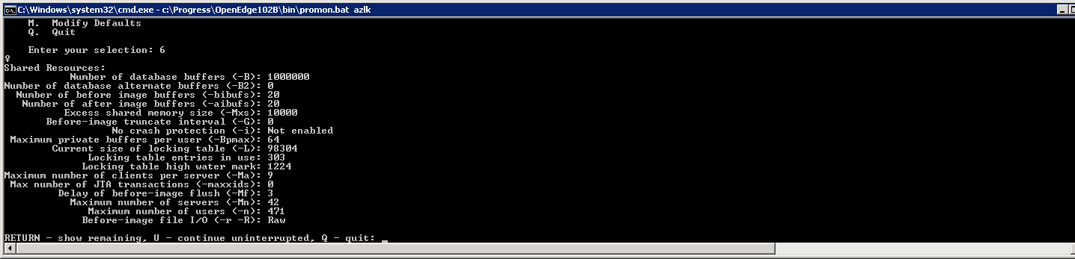

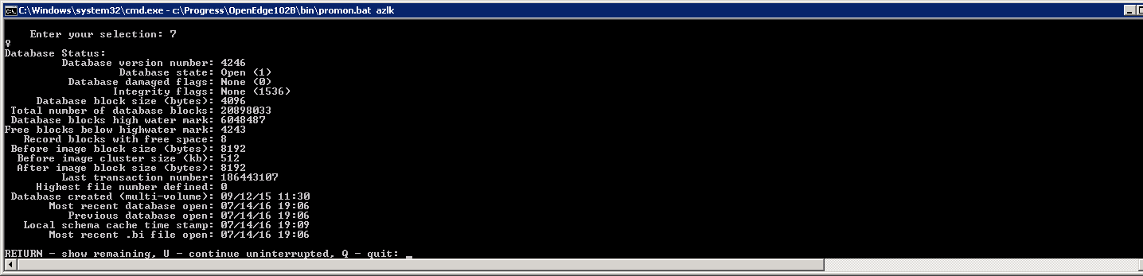

19-07-2016

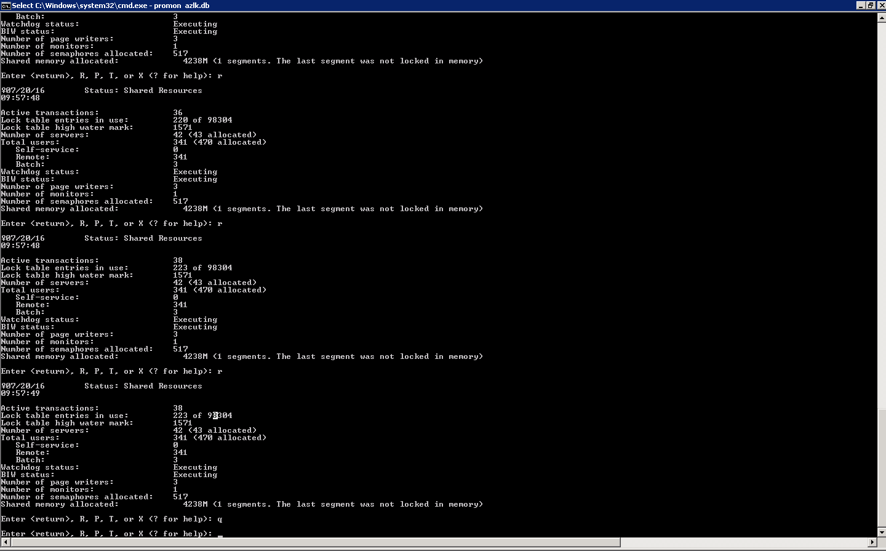

21/07/2016

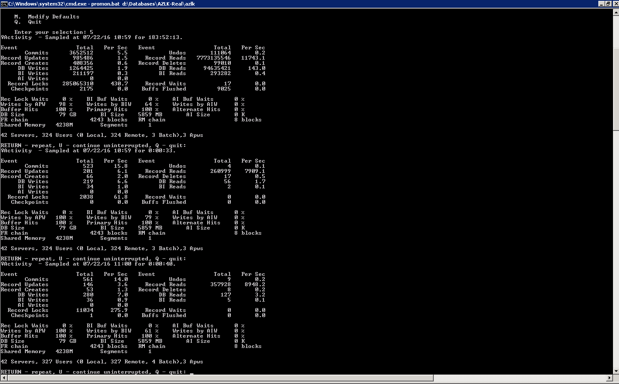

28/08

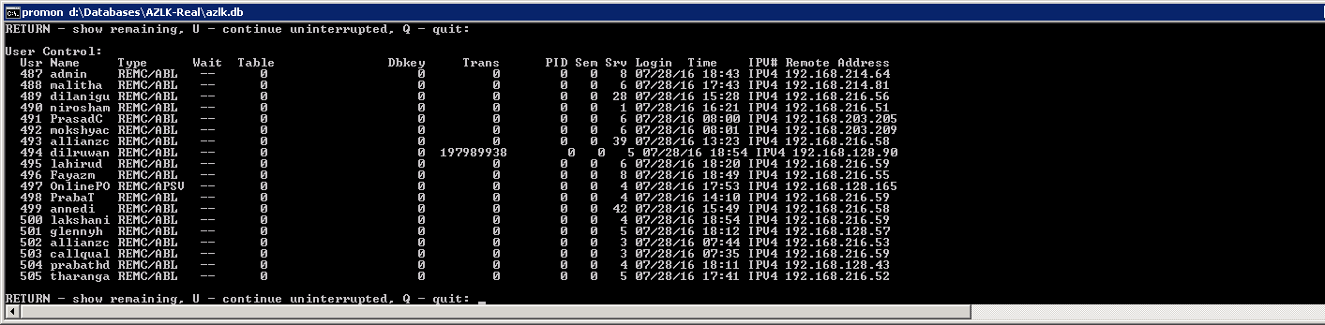

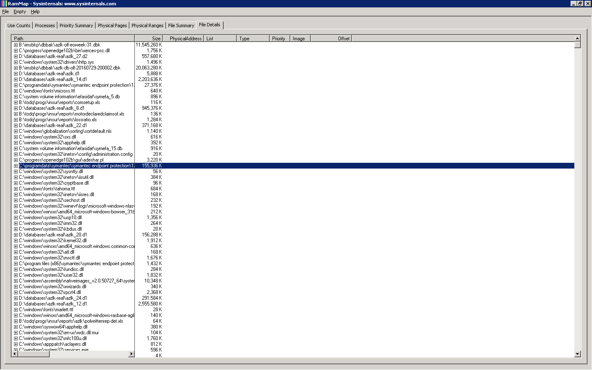

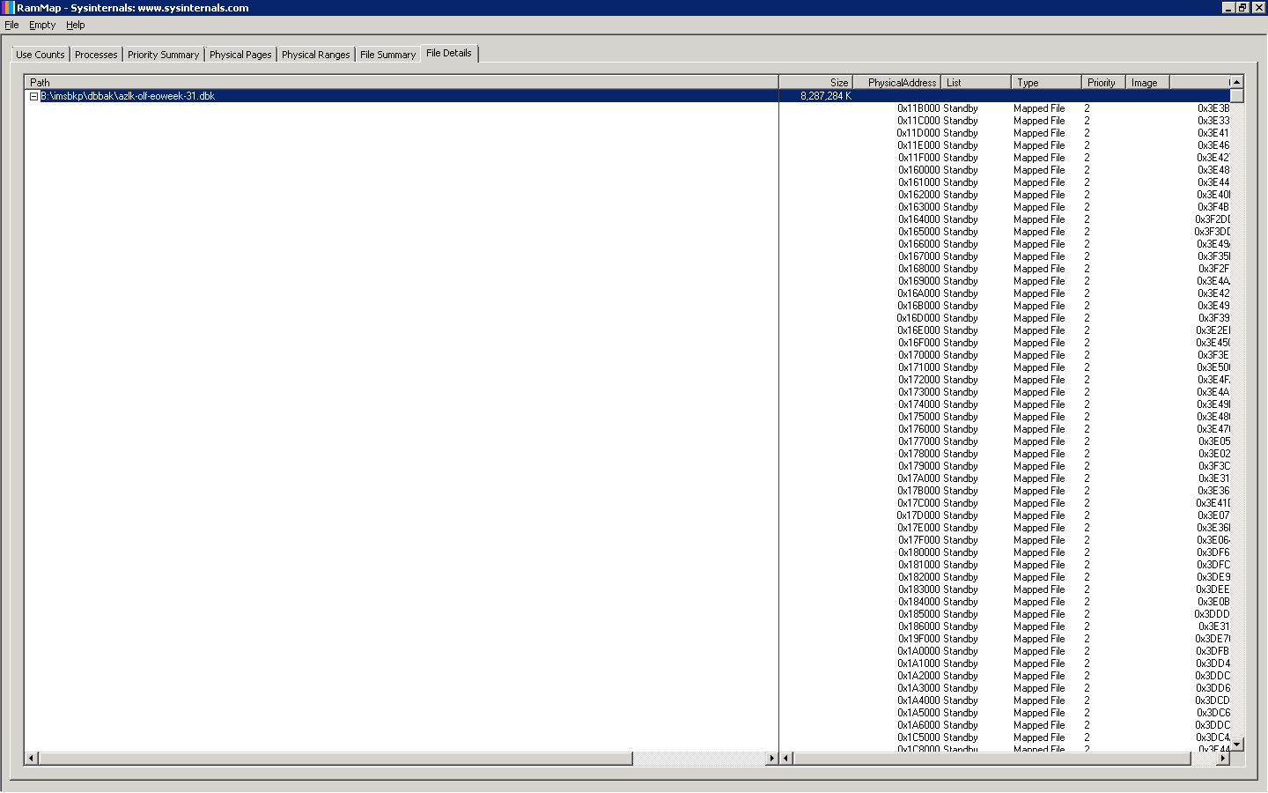

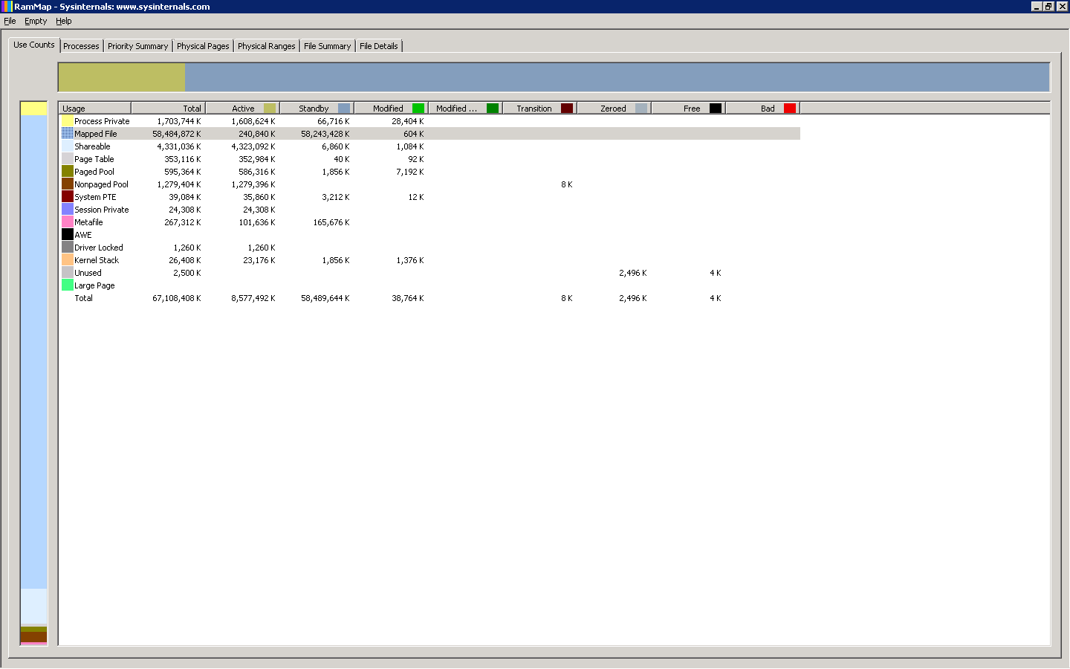

[16/07/28@14:25:02.064+2300] P-003324 T-001044 3 4GL 4GLTRACE Return from DisplayPremium [insur\PolCancl.r]

[16/07/28@14:27:27.567+2300] P-003324 T-001044 2 4GL 4GLTRACE Run DisplayPremium [USER-INTERFACE-TRIGGER - insur\PolCancl.r @ 2117]

[16/07/28@14:35:57.116+2300] P-003324 T-001044 3 4GL 4GLTRACE Return from OnQueryChange [insur\PolCom.r]

[16/07/28@14:54:10.691+2300] P-003324 T-001044 2 4GL 4GLTRACE Run OnShowChange [USER-INTERFACE-TRIGGER - insur\PolCom.r @ 3751]

Articles:

<http://knowledgebase.progress.com/articles/Article/000014375>

<http://knowledgebase.progress.com/articles/Article/P167048?popup=true>

31/07/2016

